Q1:

|  |  |  |
| --- | --- | --- |
| Train_accuracy | Test_accuracy | Training size |
| 0.58 | 0.5936 | 200 |
| 0.602 | 0.5936 | 500 |
| 0.6238 | 0.5936 | 800 |
| 0.631 | 0.5936 | 1000 |
| 0.624 | 0.5936 | 1500 |
| 0.622 | 0.5936 | 2000 |

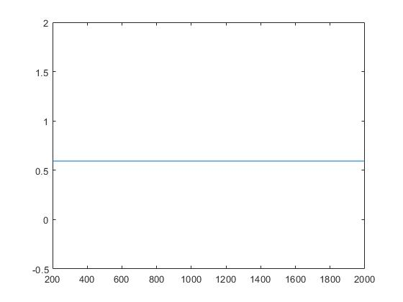

As shown in plot above, x-axis represent training set size and y-axis represent testing accuracy.

Testing performance does not change much as size of training set increases.

Q2:

Train Test Feature Reg.Param

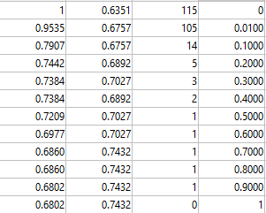

Table above are training accuracy, testing accuracy, number of features selected when choosing different regularization parameters.

Plot below are ROC curve for regularization parameters equal 0, 0.5, 1:

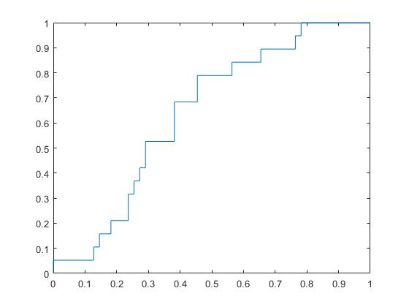

ROC for reg param = 0

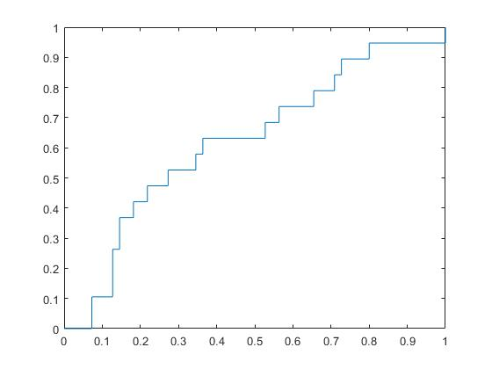

ROC for reg param = 0.5

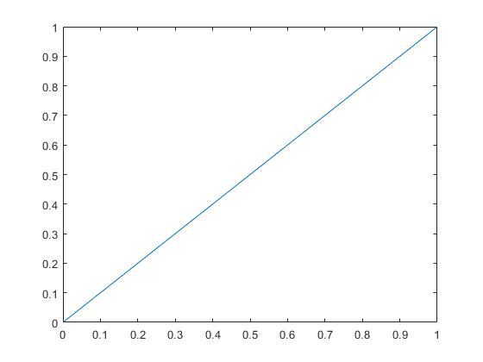

ROC for reg param = 1